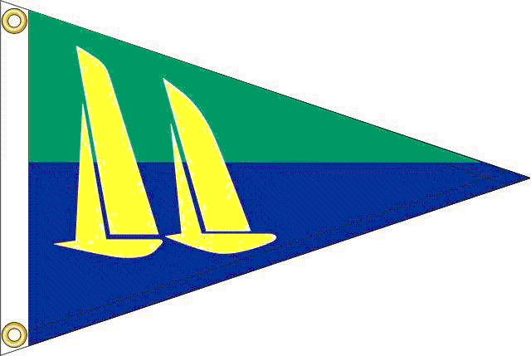

NOTICE OF RACE
Kingston Sailing Club

presents the

2013 Maritime Cup Regatta
The first of the HRYRA series of 2013 regattas
Saturday & Sunday June 1 & 2
At the Hudson River Maritime Museum, home of KSC.
All proceeds benefit the HRMM

First signals 11AM Saturday & 10:30AM Sunday. At least two races Saturday & one or two Sunday.

Breakfast, on-site registration and skippers’ meeting from 8:30am Saturday. For Notice of Race, Sailing Instructions, Courses & Registration form go to www.kingstonsailingclub.org.

Saturday: Barbecue party, beer & wine at the
Hudson River Maritime Museum – free for all skippers & crew.
Sunday: Snacks, beer & wine @ awards ceremony.

HRMM slips with water, shore power & showers available at reduced rate of $1.00/foot for out-of-town boats. Reserve with your registration.

For more information contact
Commodore Ian Westergren (ian@spw.com) or Regatta Chairman John Stephenson (jstephenson@hvc.rr.com).

